SIMPLE BLOOD DONATION CAMP MANAGER
@CREATIVITY THINK (9483175986/7019689991)

ABSTRACT:
Simple Blood Donation Camp Manager is a web-based system designed to organize and manage blood donation camps efficiently. The platform enables donor registration, eligibility verification, slot booking, and certificate generation while providing administrators with tools to manage camps, track attendance, and analyze donor data. Built with Django and Django REST Framework for backend operations, and React with react-table and axios for frontend interactions, the system ensures smooth coordination between donors and organizers, encourages timely donations, and maintains a structured donor database for hospitals, blood banks, NGOs, and colleges..

INTRODUCTION OF THE PROJECT:
Blood donation camps are critical for maintaining a healthy blood supply but organizing them manually often results in inefficiencies, scheduling conflicts, and difficulty tracking donor eligibility. Traditional approaches lack a centralized platform for registration, slot management, and data analytics. Simple Blood Donation Camp Manager addresses these challenges by offering an organized, digital solution for registering donors, checking eligibility based on donation intervals, booking appointments, and generating certificates. Administrators gain oversight of all camps, registrations, and donor analytics, improving operational efficiency and engagement..

PROJECT OBJECTIVES:

• Provide a platform for donor registration and profile management
• Allow donors to browse upcoming camps and available slots
• Automatically verify eligibility based on last donation and gap days
• Enable slot booking and attendance tracking
• Generate PDF thank-you certificates for donors
• Allow administrators to create and manage camps and slot limits
• Monitor donation status and donor attendance
• Analyze donor data including blood group distribution
• Send appreciation messages and export donor database for reporting

PROBLEM OF THE STATEMENT:
Blood donation drives often face challenges in coordinating donors, ensuring eligibility, managing appointments, and maintaining accurate records. Manual tracking is time-consuming and prone to errors, while communication with donors can be inefficient. Simple Blood Donation Camp Manager addresses these issues by centralizing registration, eligibility checks, slot management, and analytics, providing a structured workflow for both donors and administrators..

MOTIVATION OF THE PROJECT:
• To streamline donor registration and camp management
• To ensure donors meet eligibility criteria and avoid conflicts
• To provide an organized scheduling and booking system
• To maintain accurate attendance and donation records
• To improve communication and engagement with donors
• To provide actionable analytics for camp organizers
• To enhance efficiency for hospitals, NGOs, and colleges managing blood drives
• To generate certificates and automate acknowledgment for donors

BLOCK DAIGRAM OF PROJECT:

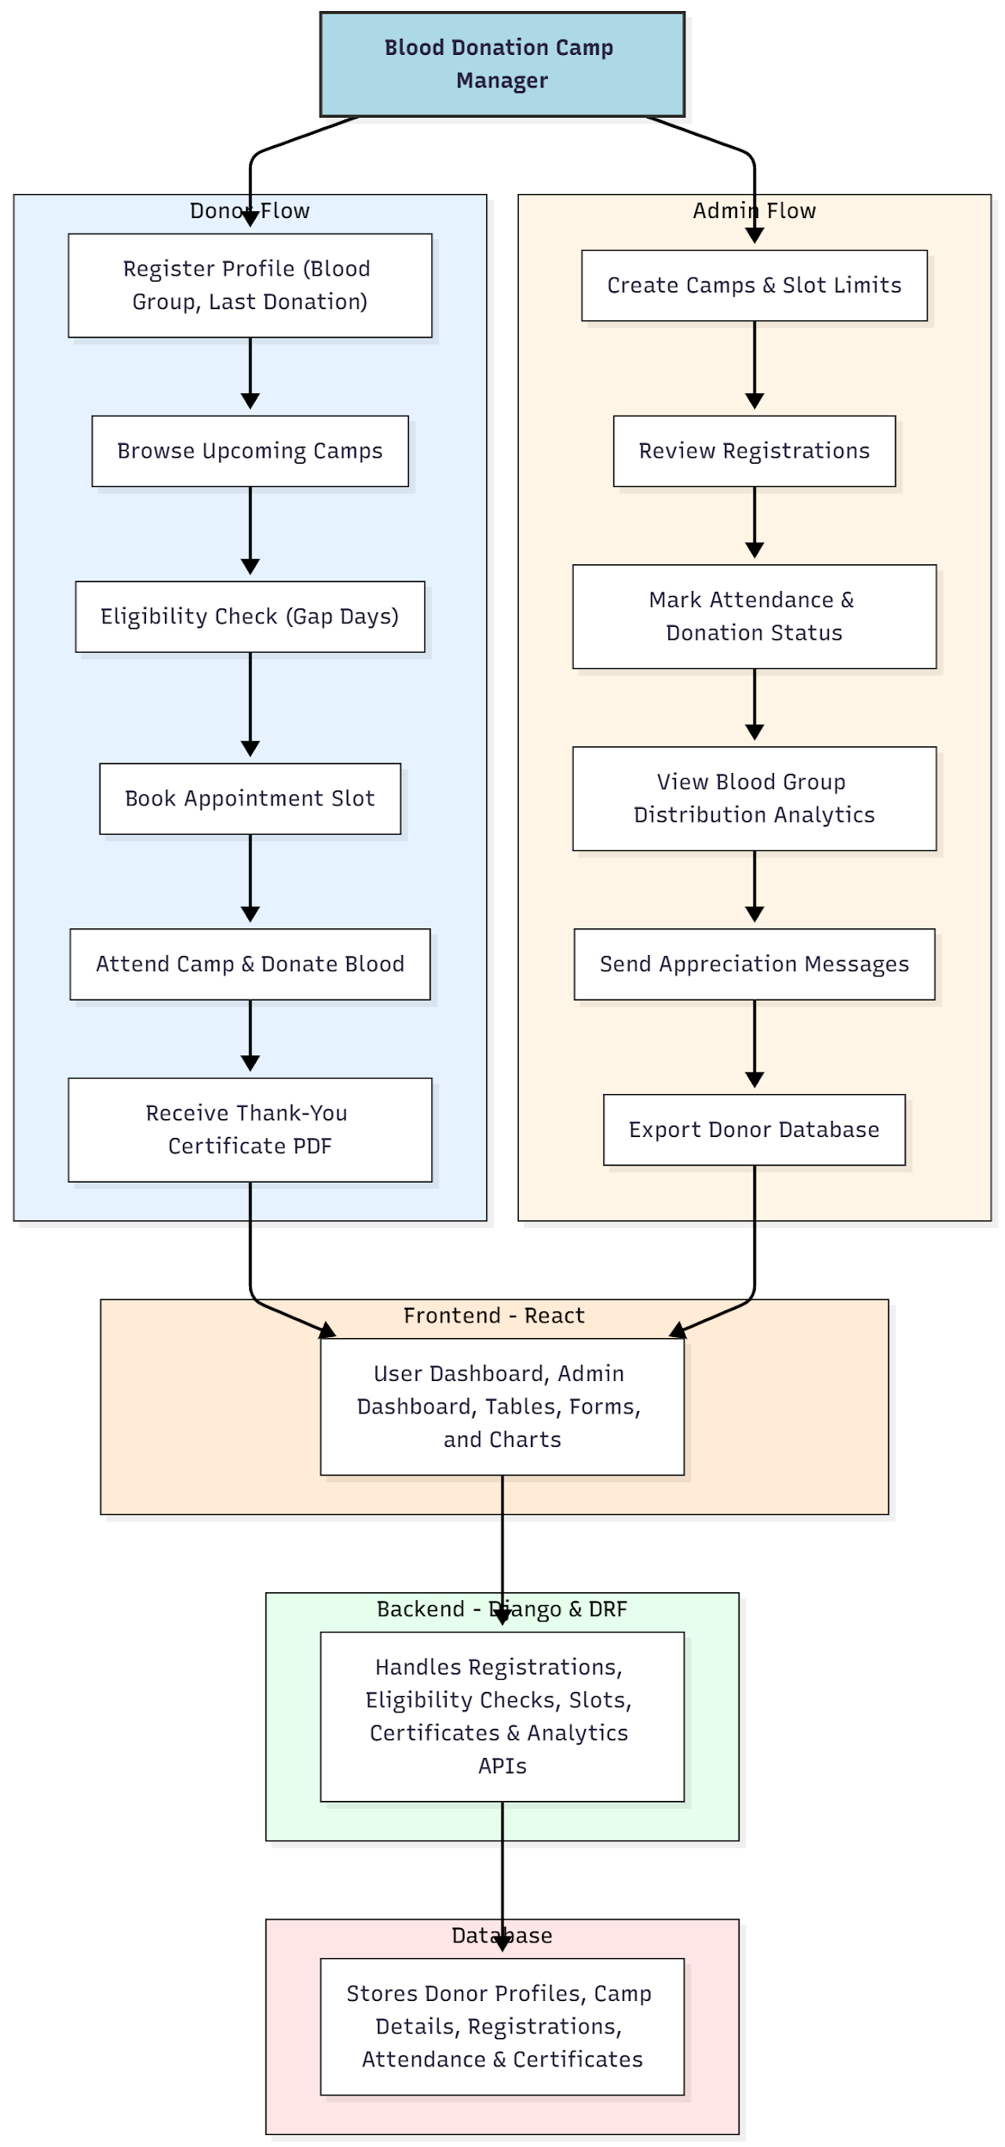

WORKING OF THE PROJECT:
Donors register their profiles, including blood group and last donation date. They can browse upcoming camps, where the system checks eligibility based on gap days. Eligible donors book available appointment slots and attend the camp. Upon donation, a PDF thank-you certificate is generated. Administrators create camps with slot limits, monitor registrations, track attendance and donation status, view blood group distribution analytics, send appreciation messages, and export the donor database. The backend handles all API requests, eligibility logic, slot management, certificate generation, and analytics, while the frontend provides user and admin dashboards with interactive forms, tables, and charts. The database maintains structured records of donors, camps, attendance, and certificates..

SOFTWARE REQUIREMENT:
- Backend:
  - Python 3.x
  - Django
  - Django REST Framework
  - SQLite/PostgreSQL
- Frontend:
  - Node.js and npm
  - React.js
  - Axios
- Development Tools:
  - Visual Studio Code
  - Postman (for testing APIs)
  - Git/GitHub (for version control)
- Server/Deployment (Optional):
  - Gunicorn, Nginx, or Heroku/AWS for hosting

ADVANTAGES OF THE PROJECT:

• Streamlines donor registration and camp management
• Automates eligibility verification and slot booking
• Maintains accurate donor and camp records
• Generates certificates automatically
• Provides analytics and insights for blood donation trends
• Improves communication with donors through notifications
• Supports hospitals, blood banks, NGOs, and colleges
• Enhances operational efficiency and donor engagement

APPLICATIONS OF THE PROJECT:
• Hospitals and blood banks
• Non-governmental organizations organizing blood drives
• College and university blood donation camps
• Community health events
• Any institution conducting organized blood donation campaigns

REFERENCES:

- Django REST Framework Documentation — Django Software Foundation. Django Documentation. Available: https://docs.djangoproject.com/
- Django REST Framework. DRF Documentation. Available: https://www.django-rest-framework.org/
- React. React Official Documentation. Available: https://reactjs.org/docs/getting-started.html
- Redux. Redux Documentation. Available: https://redux.js.org/introduction/getting-started
- PostgreSQL Global Development Group. PostgreSQL Documentation. Available: https://www.postgresql.org/docs/
- MySQL. MySQL Reference Manual. Available: https://dev.mysql.com/doc/
- Git. Git Documentation. Available: https://git-scm.com/doc
- Node.js. Node.js Documentation. Available: https://nodejs.org/en/docs/
- Axios. Axios Documentation. Available: https://axios-http.com/docs/intro
- Socket.io Documentation – https://socket.io/docs/

